**Problem Statement**

I created two spheres and attached cylinders that rotate simultaneously vertically and horizontally. Another cylinder perpendicular to these structures rotates with the same velocity horizontally. Four viewports display this object from the front, from the side, and from above, with the last viewport the display starts from the front but can be adjusted with menu commands roll, pitch, yaw, and slide (zoom), as well as using the WASD keys to move around the X and Z axes, and R and F to go up and down. In addition, the camera can zoom in and out with the slide command.

**Algorithm Design**

The key to the movement of the structure was to properly create the matrix stack. In order to rotate around a certain point, one must translate to the origin, perform the rotation, and then translate back. However, as we don’t want the vertical arms to rotate around a specific point, we modify the algorithm by not first translating forward, so the horizontal rotation is centered at the origin, but actively revolves around the origin instead of rotating in place. The concept is similarly applied to the vertically rotating arms, except first centered at the edge of the vertical bar. The matrices involved in these rotations are only the rotate translate matrices, with translate used to center the rotations for correct calculations. The rotation angle is taken care of by a variable that is increased by a set amount at every call of the display function. This is how the rotation is continuous. Moving around independent of the camera is done by WASD for X and Z axes, and RF for the Y axis. These commands modify both the XYZ of the camera as well as the XYZ of the origin.

**How to Run the Code**

Double click the .exe to run. Right-click to see the options, and use WASD to move around horizontally, and RF to move around vertically. Email me at [lwisdom1@binghamton.edu](mailto:lwisdom1@binghamton.edu) if you have any questions.

**Screenshots**

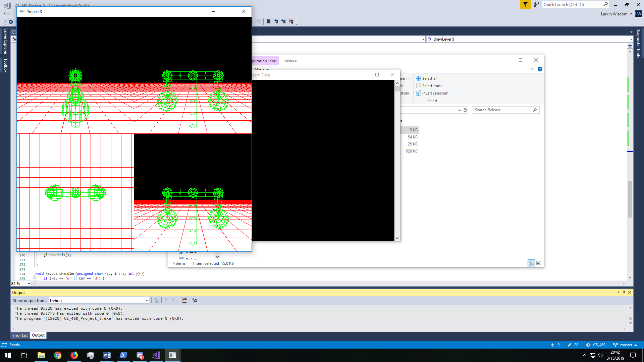

Default position

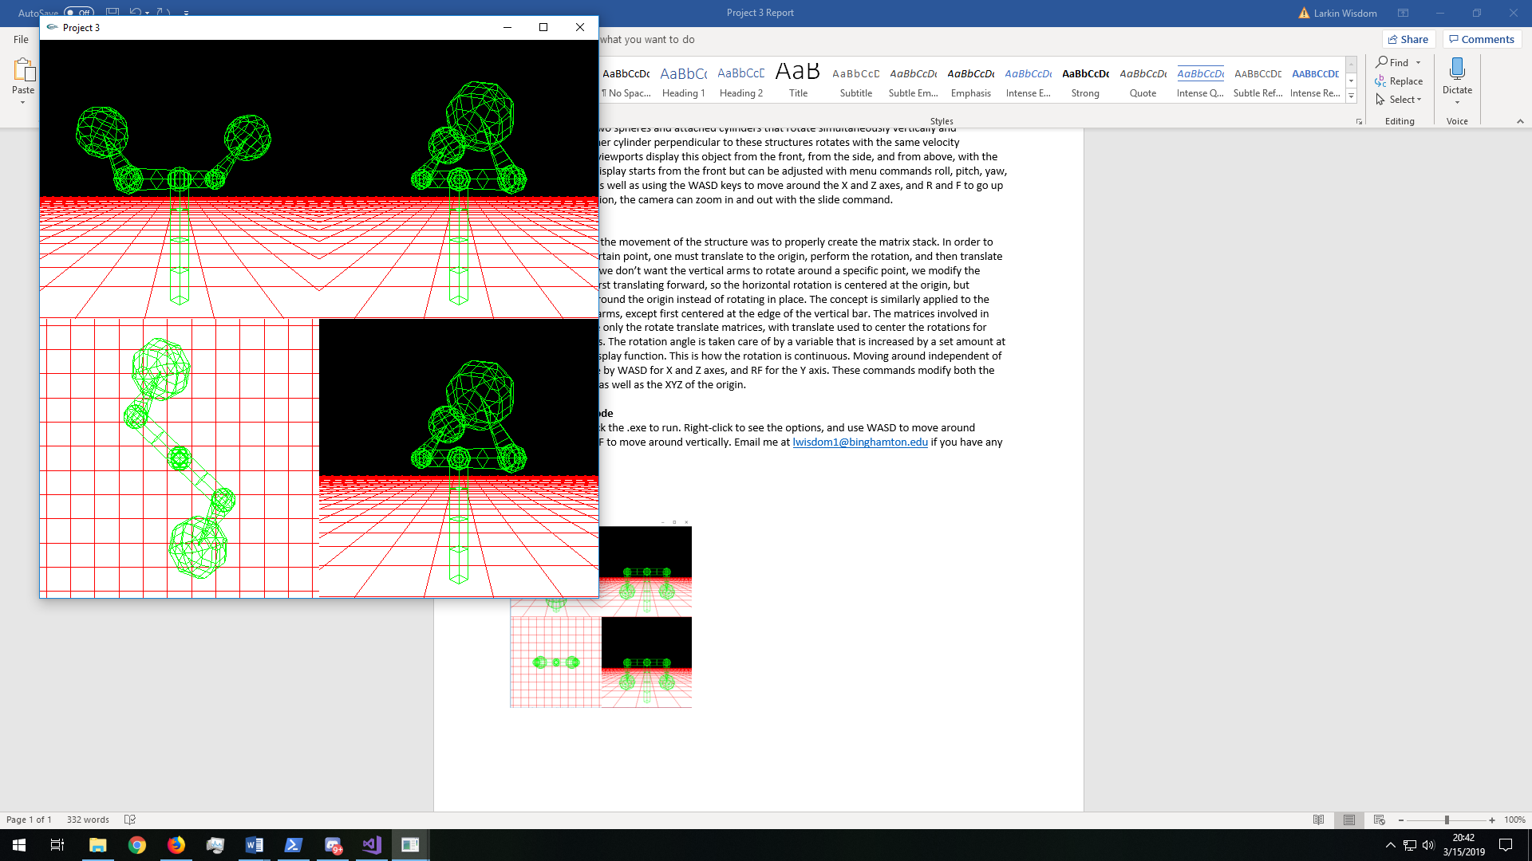

Rotation

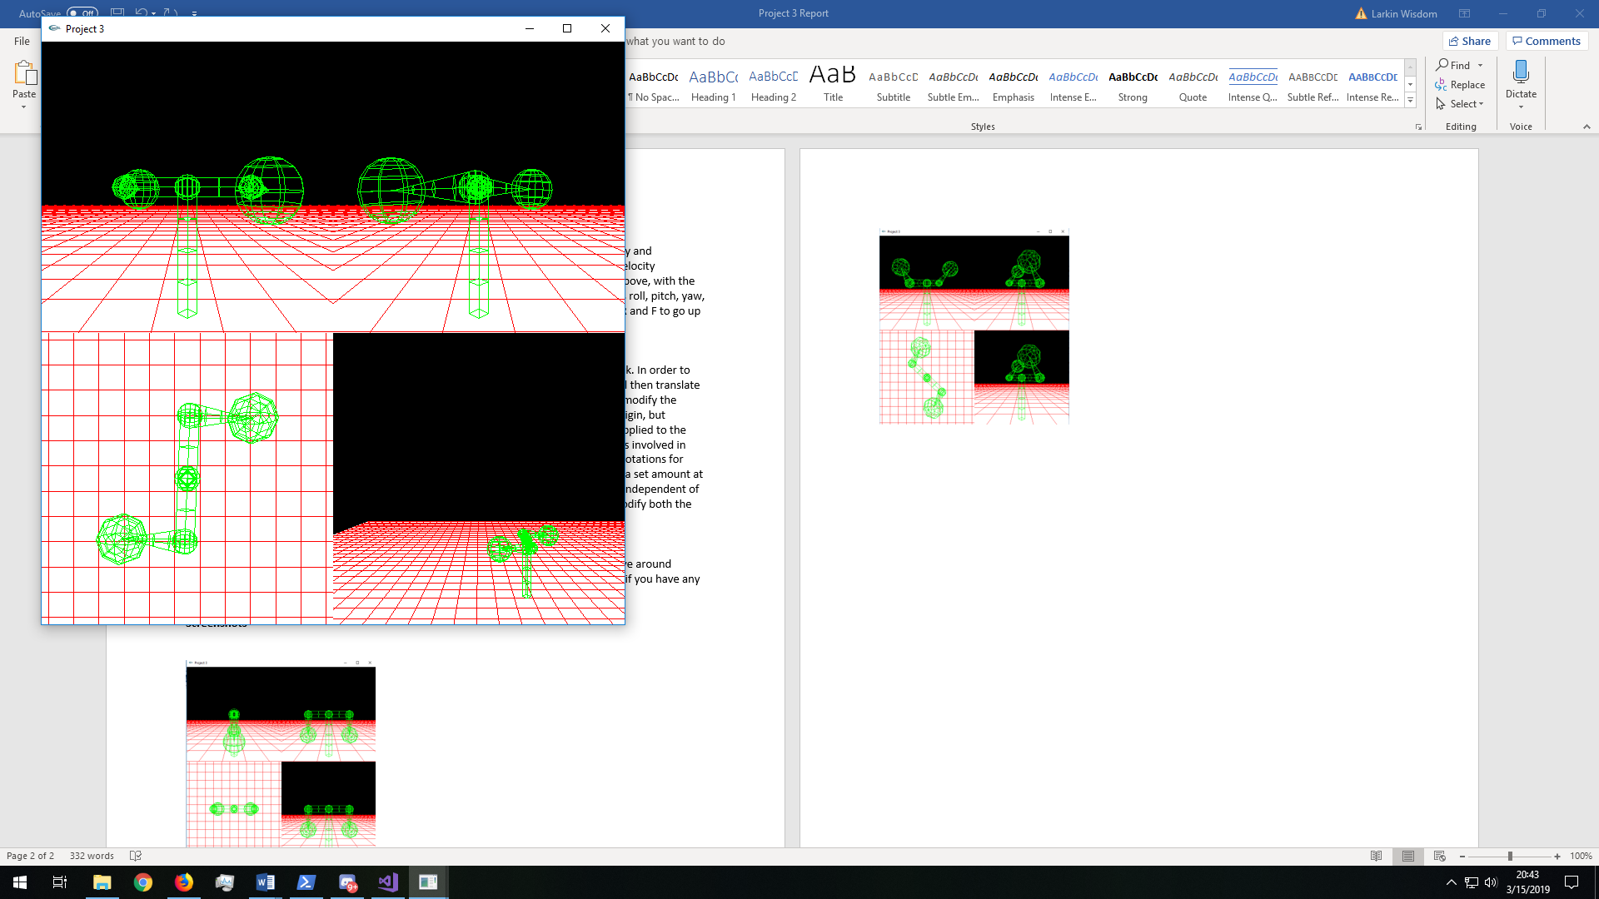

Using WASD and RF to move away from the object

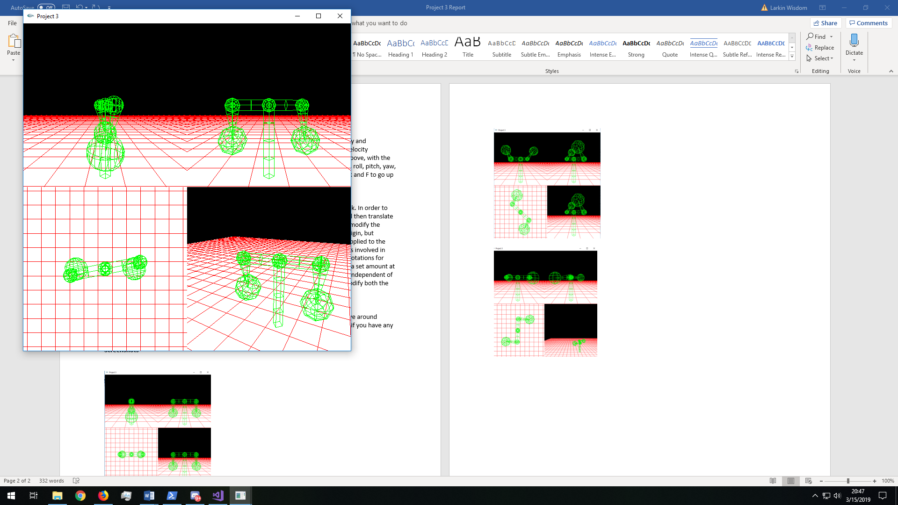

Demonstrating pitch/yaw/roll